SPECTRE / MACS3 eComms
Lexicon Surveillance Platform
Lexicon Scanner Service
Complete Technical Reference — Cloud Run Service
Covers the complete implementation: scan pipeline, request types,
HTML content handling and offset mapping, disclaimer exclusion, multi-message
scanning, AND NOT enforcement, Hyperscan flags and complexity handling,
exception handling, the downloadable report, and the complete REST API surface.
Document version 1.0
Reflects the complete current implementation, ground-truthed against source

Table of Contents

1. Executive Summary
The Lexicon Scanner Service is a Spring Boot 4 / Java 21 microservice, deployed on Google Cloud Run, providing an interactive UI and REST API for compliance analysts and lexicon authors: compile a set of lexicon terms via the Lexicon Compile Service, scan one or more messages against them, see exactly what matched and why (or why not), exclude disclaimer boilerplate from alerting, and export a complete audit report. It is the primary way a lexicon rule is tested and refined before being promoted to the batch Lexicon Scan Engine.
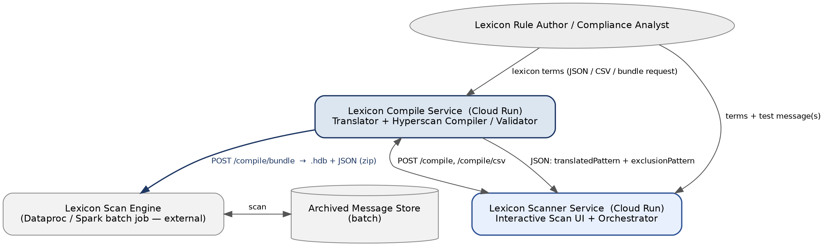
Figure 1: The Scanner Service's place in the wider platform — it is a genuine client of the Compile Service's JSON API, and runs its own embedded Hyperscan instance to actually scan message text.

1.1 Scope of This Document
This document describes the complete current implementation of the Lexicon Scanner Service — the full feature set as it exists today: the scan pipeline and control flow, request types (Natural Language and Regex), HTML content handling and the original-text coordinate mapping it depends on, disclaimer exclusion, multi-message scanning, the two-pass Hyperscan scan that enforces AND NOT, the complete Hyperscan flag model as used by this service, exception handling, validation, the downloadable audit report, and the REST API.

1.2 Technology Stack
Layer | Choice
Language / Runtime | Java 21, Spring Boot 4.0.6
Pattern engine | Intel Hyperscan 5.4.0-2.0.0, via the com.gliwka.hyperscan-java wrapper — this service runs its own embedded Hyperscan instance, separate from the Compile Service's
Upstream dependency | Lexicon Compile Service, called via Spring's RestClient for Natural Language term resolution
CSV parsing | OpenCSV — reused identically for both lexicon-term CSVs and disclaimer CSVs
Deployment | Google Cloud Run
Base package | com.db.macs3.ecomms.spectre

2. Architecture and Deployment

2.1 Relationship to the Compile Service
The Scanner Service is a genuine HTTP client of the Compile Service's JSON API — it does not reimplement any translation logic. It calls POST /compile or POST /compile/csv, reads the JSON response (translatedPattern, exclusionPattern, requiresExclusionCheck, hyperscanFlags, compilationStatus), and then compiles and scans the returned patterns using its OWN, separately-embedded Hyperscan instance. The Compile Service is called ONCE per scan request, regardless of how many messages are being scanned in that request — the resulting compiled term set is reused across every message.

2.2 Deployment
Property | Value
Platform | Google Cloud Run (containerised, stateless, auto-scaling)
Upstream configuration | Compile Service base URL and timeouts configured via AppProperties, injected into a pre-configured RestClient bean (RestClientConfig)
Static assets | The interactive UI (index.html and assets) is served directly from /static/ by this same Spring Boot application — no separate frontend deployment
Health check | GET /api/scan/health — service status and key configuration values (Compile Service URL, max terms)

3. Scan Pipeline (Control Flow)
For every scan request, the orchestrator (LexiconScanOrchestrator) resolves the term set, message set, and disclaimer set once, then runs a per-message sequence for each message independently.
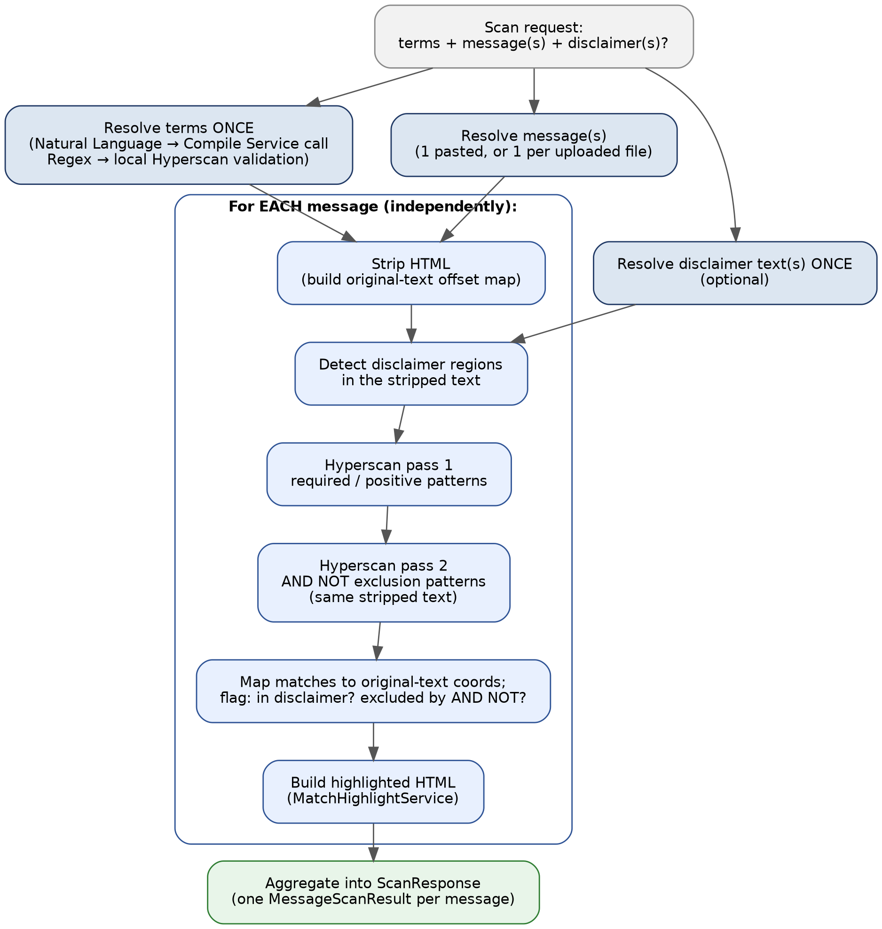
Figure 2: The complete scan control flow. Terms, disclaimers, and messages are each resolved once; the six-step inner sequence repeats independently per message.

3.1 Once-Per-Request Resolution
Step | What happens
Resolve terms | Natural Language → one call to the Compile Service (POST /compile or /compile/csv). Regex → each term validated individually against this service's own embedded Hyperscan instance, so one bad regex in a CSV batch fails only that term.
Resolve disclaimer(s) | Optional. Parsed once from typed text or an uploaded CSV (same format and parser as lexicon-term CSVs).
Resolve message(s) | One pasted message (labelled "Pasted Message"), or one message per uploaded file.

3.2 Per-Message Sequence
Step | Component | What happens
1. Strip HTML | HtmlStrippingService | Builds the stripped text Hyperscan actually scans, plus an original-text offset map (section 5).
2. Detect disclaimers | DisclaimerDetectionService | Finds every disclaimer occurrence in the stripped text, mapped back to original-text coordinates (section 6).
3. Scan pass 1 | HyperscanScanService | Required/positive patterns for every term, scanned together.
4. Scan pass 2 | HyperscanScanService | AND NOT exclusion patterns for every term that has one, scanned together against the SAME stripped text (section 7).
5. Map and flag | LexiconScanOrchestrator | Matches mapped to original-text coordinates; each flagged inDisclaimer and/or excludedByAndNot.
6. Build highlighted HTML | MatchHighlightService | The rendered, highlighted version of the ORIGINAL message text (not the stripped text) the UI displays.

4. Request Types: Natural Language and Regex
Mirrors the Compile Service's own TermType exactly, including its display strings ("Natural Language" / "Regex"), so the same wording is used end-to-end from the UI through to the downloadable report's Request Type column.
Type | Term resolution | Who validates the pattern
Natural Language (default) | One call to the Compile Service (POST /compile or /compile/csv) for the whole term set | The Compile Service — full pipeline: Tokenizer, ExpressionParser, PatternComplexityAnalyzer, PatternCodeGenerator, then real Hyperscan validation. The Scanner Service does not re-validate; it trusts the Compile Service's PASS/FAILED status per term.
Regex | No Compile Service call at all — each term is a caller-supplied PCRE pattern | This service's own HyperscanScanService.validatePattern(), which compiles the pattern through this service's own embedded Hyperscan instance directly. Each term validated individually, so one bad regex in a batch fails only that term.

Important distinction from the Compile Service
For Regex-type terms scanned directly by this service, there is no pattern-complexity pre-check (section 9) — only Hyperscan's own real-time compile rejection. This is covered precisely in section 9.

5. HTML Content Handling
A term like (Enjoy) FOLLOWEDBY{2} (Happy) translates to a regex requiring whitespace between the two words. A message such as "<p>Enjoy</p>\n<p>Happy Birthday</p>" would never match that regex as written, because the two words are separated by HTML markup, not whitespace. HtmlStrippingService exists to solve exactly this problem, while preserving the ability to highlight a match at its TRUE position in the original text the user actually pasted.
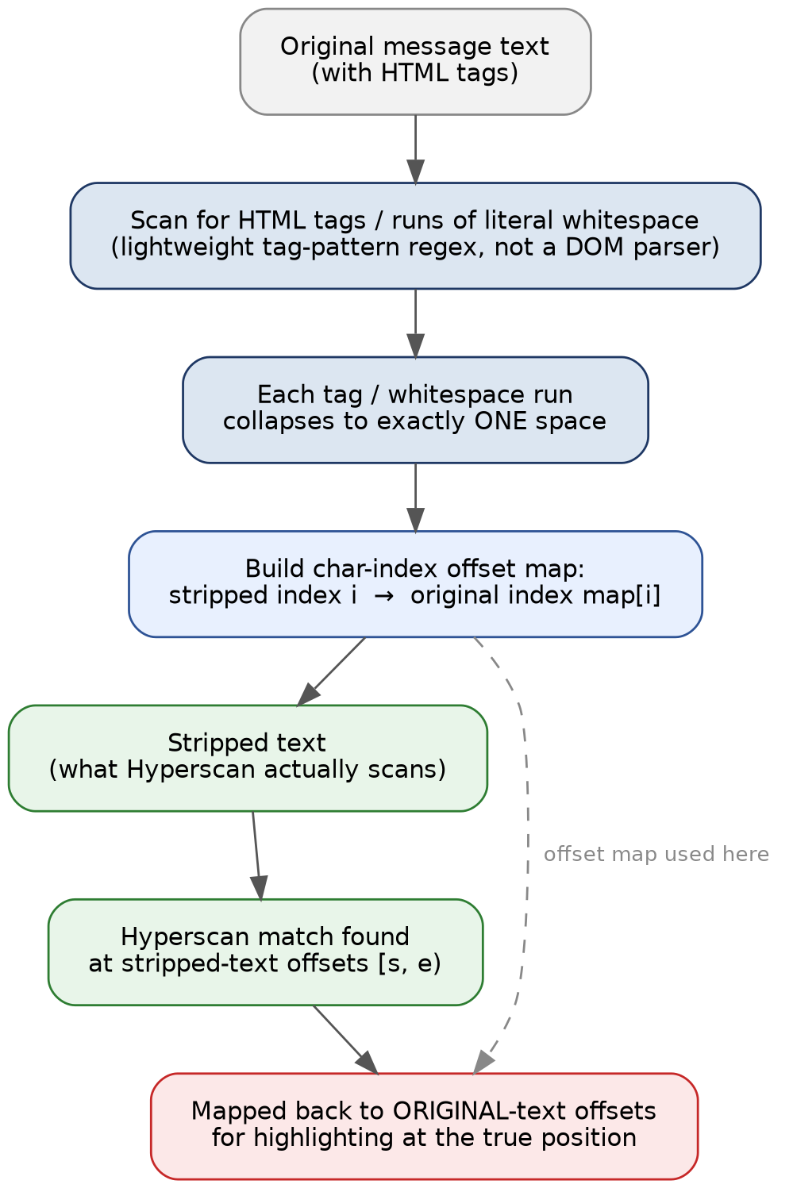
Figure 3: HTML stripping and the original-text offset map. Hyperscan scans the stripped text; every match is mapped back to original-text coordinates before being shown to the user.

5.1 Stripping Algorithm
Each HTML tag (or run of literal whitespace) is replaced with exactly one space, turning "<p>Enjoy</p>\n<p>Happy Birthday</p>" into "Enjoy Happy Birthday", which matches the FOLLOWEDBY pattern correctly.

5.2 Why Not a Real HTML/DOM Parser
A full HTML/DOM parser is deliberately not used. Compliance messages in this platform are simple chat/email fragments, not full HTML documents, so a lightweight, well-formed-tag-only regex is sufficient and considerably cheaper to run at scan volume. A stray '<' in ordinary text ("if a < b then...") does not match the tag-recognition pattern and is left as an ordinary character — real content is never silently eaten by an overly aggressive tag matcher.

5.3 The Offset Map
As the stripped text is built, a parallel array records, for every character in the stripped text, its corresponding character index in the ORIGINAL text. Hyperscan reports match positions in terms of the stripped text (since that is what it scanned); every reported match position is converted back to an original-text position via this map before being used for anything the user sees — highlighting, the downloadable report, or disclaimer-containment checks (section 6).

5.4 A Fixed Bug: Coordinate-System Mixing in Highlight Merging
Large, HTML-heavy messages could previously crash the scan with a StringIndexOutOfBoundsException ("Range [x, y) out of bounds for length y") during highlight merging. The cause: when two lexicon matches overlap and need to be merged into one highlighted span, the merge logic computed a substring index using ORIGINAL-text character positions and applied that index to a string drawn from the STRIPPED text — two different coordinate systems, with different lengths whenever HTML markup sits between the two matches. For a message with substantial markup, the original-text distance could vastly exceed the shorter stripped-text string's own length, causing the computed index to exceed the string's length and throw.
The fix removes the unsafe cross-coordinate-system computation entirely. This was safe to do because the value being computed (a precisely-reconstructed merged matchedText string) is never actually used for rendering — the highlighted HTML is built by slicing the ORIGINAL message text directly at the match's start/end character indices, not from that field. The merge now uses simple string concatenation, which cannot throw, since nothing downstream depends on the value being a precise reconstruction.

6. Disclaimer Handling
Email disclaimers often contain words that also appear meaningfully in the message body — "confidential" being the canonical example. A lexicon match found only inside a disclaimer must not trigger a false alert, but should still be visible to the analyst with a clear "not an alert" indication rather than being silently discarded.
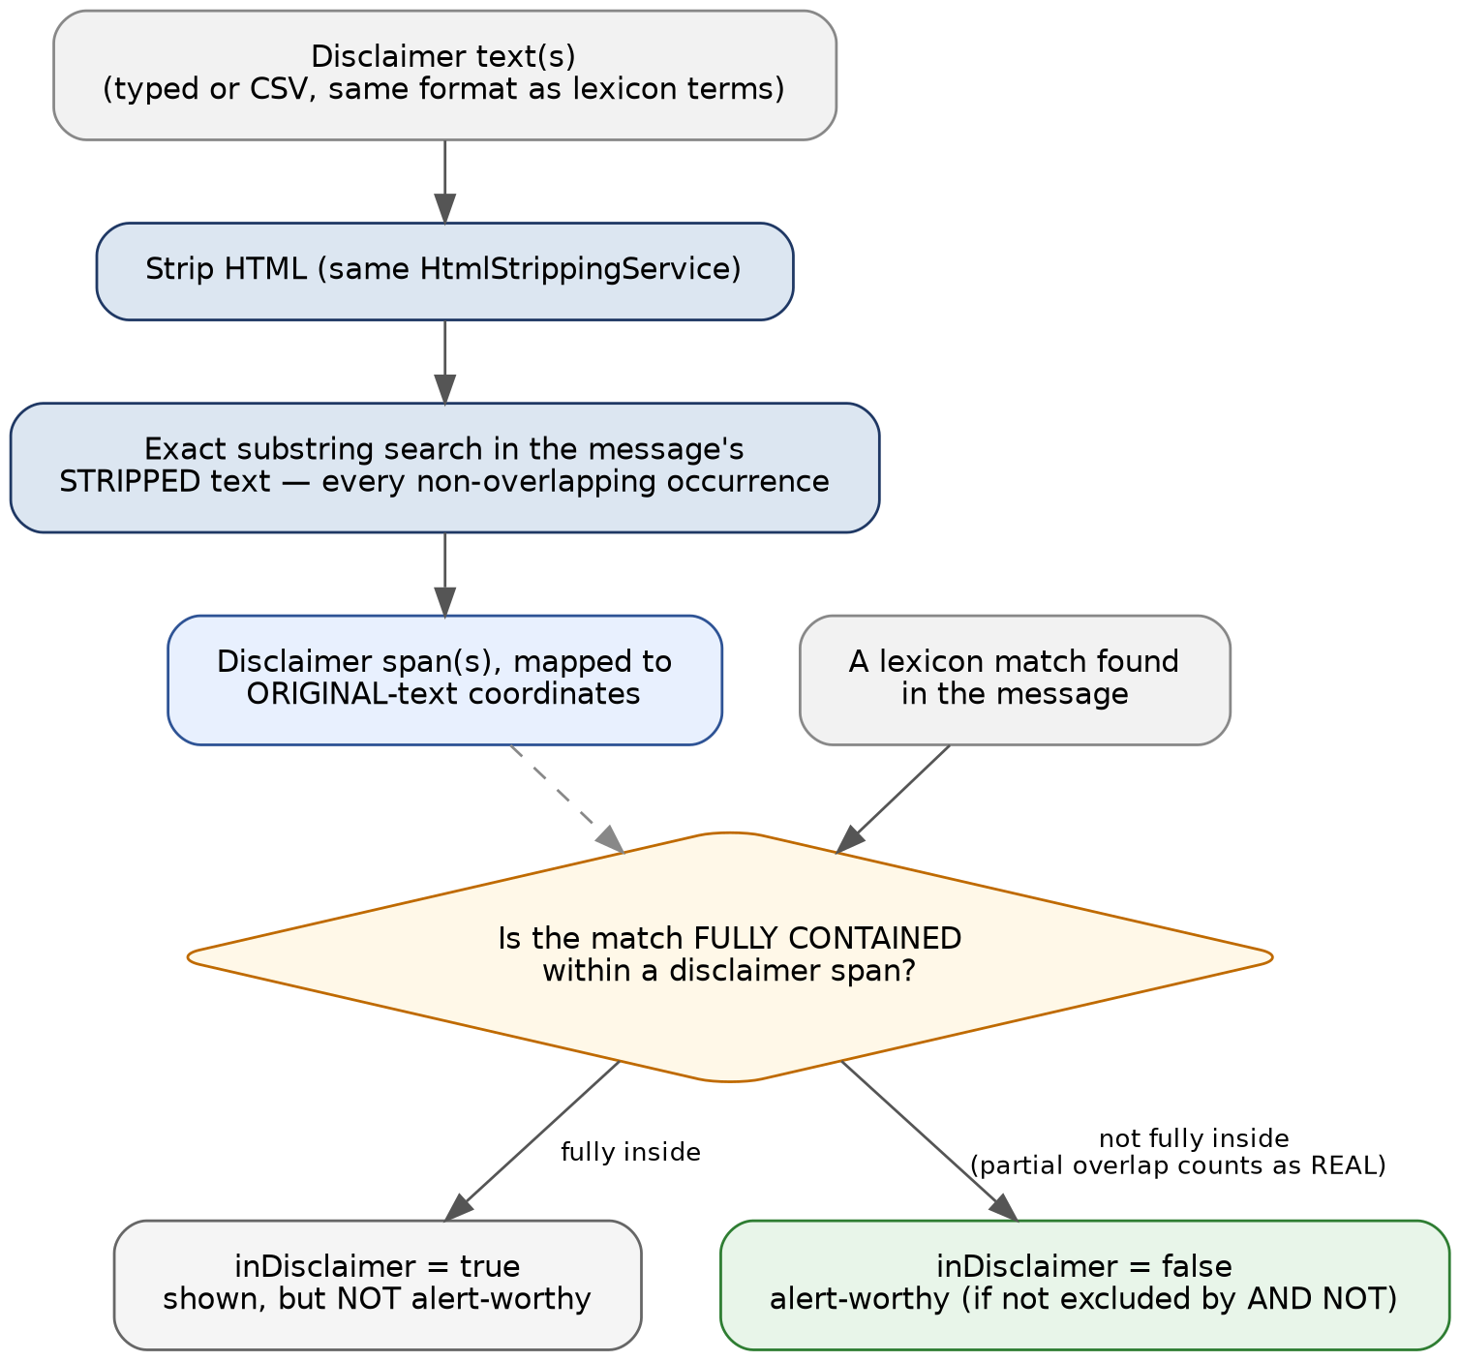
Figure 4: Disclaimer detection and the containment rule that decides whether a match counts toward alerting.

6.1 Detection Strategy: Exact Substring Match on Stripped Text
Each supplied disclaimer text is run through the same HtmlStrippingService used for the message itself (section 5), then searched for as a literal substring within the message's stripped text. This deliberately does not attempt fuzzy or approximate matching — organisations almost always append the exact same boilerplate disclaimer text verbatim, and exact substring matching on already-normalised text is simple, fast, and easy for an analyst to reason about.
Every non-overlapping occurrence of every supplied disclaimer is found, not just the first, and every found span is mapped back to original-text coordinates using the same offset map lexicon matches use (section 5.3).

6.2 Containment, Not Overlap
A lexicon match is only treated as disclaimer-only when it falls ENTIRELY within a detected disclaimer span. A match that starts inside a disclaimer but extends beyond it into real message content is NOT suppressed — the safer choice for a compliance tool is to never let a boundary case hide a genuine alert. This asymmetry is deliberate: false negatives (missing a real alert) are a materially worse outcome than false positives (an occasional disclaimer-boundary match still counting as alert-worthy).

6.3 Supplying Disclaimers
Mirrors the lexicon-term input pattern exactly: type one or more disclaimers directly (separated by a blank line, since a single disclaimer commonly spans several lines — unlike a lexicon term, which is always one line), or upload a CSV using the same two-column format and the same parser as a lexicon-term CSV (CsvParserService), reusing rather than duplicating the parsing logic.

6.4 What the Analyst Sees
A match found only within a disclaimer is still shown in the UI, highlighted in a visually distinct (muted) style, with a note explaining it does not count toward alerting. It is never silently dropped — the analyst can always see the full set of raw pattern hits, with the alerting decision made transparent rather than hidden inside the count.

6.5 Known Limitation
Disclaimer matching is exact-substring only. A disclaimer that varies between messages — for example, one templated with a per-message date, sender name, or account number — will not be detected by this mechanism, since even a single differing character breaks an exact substring match. This is a deliberate simplicity/robustness tradeoff, not an oversight: fuzzy matching would introduce its own false-negative and false-positive risk that is harder for an analyst to reason about than "the text must match exactly".

7. Operator Handling: How the Scanner Consumes Compiled Patterns
The Scanner Service does not implement the operator language itself — that is entirely the Compile Service's responsibility (Tokenizer, ExpressionParser, PatternCodeGenerator). What the Scanner Service does is consume the RESULT of that translation correctly, which for most operators (OR, AND, NEAR, FOLLOWEDBY, wildcards, quoted phrases, multi-language, emoji) means simply: compile the returned translatedPattern into this service's own Hyperscan instance and scan with it, exactly like any other single pattern. AND NOT is the one operator that requires genuine additional logic in this service, covered in full in section 8.

7.1 CompiledTerm: the Scanner's Internal Representation
Regardless of whether a term came from the Compile Service (Natural Language) or was supplied directly (Regex), it is normalised into the same internal CompiledTerm shape before scanning — termId, termDescription, the pattern string, the Hyperscan flag bitmask, whether it requires an exclusion check, and an expression index used to correlate a raw Hyperscan match back to which term produced it. This uniform representation is what lets the rest of the pipeline (scanning, highlighting, disclaimer flagging, report generation) treat both term types identically after resolution.

7.2 One Combined Hyperscan Database Per Scan
Every term's required pattern is compiled into ONE combined multi-pattern Hyperscan database for the required-pattern scan pass, rather than one database per term — this is both significantly faster (Hyperscan is designed for exactly this multi-pattern use case) and is what makes a single scan pass report which of potentially dozens of terms matched, each identified by its expression index.

8. AND NOT Enforcement: The Two-Pass Scan
This section documents, in detail, how this service turns the Compile Service's two-pattern AND NOT contract (translatedPattern + exclusionPattern) into a real, correct scanning behaviour — including the story of a real integration bug this exact mechanism replaced, because the reasoning explains several design choices that would otherwise look like unnecessary complexity.
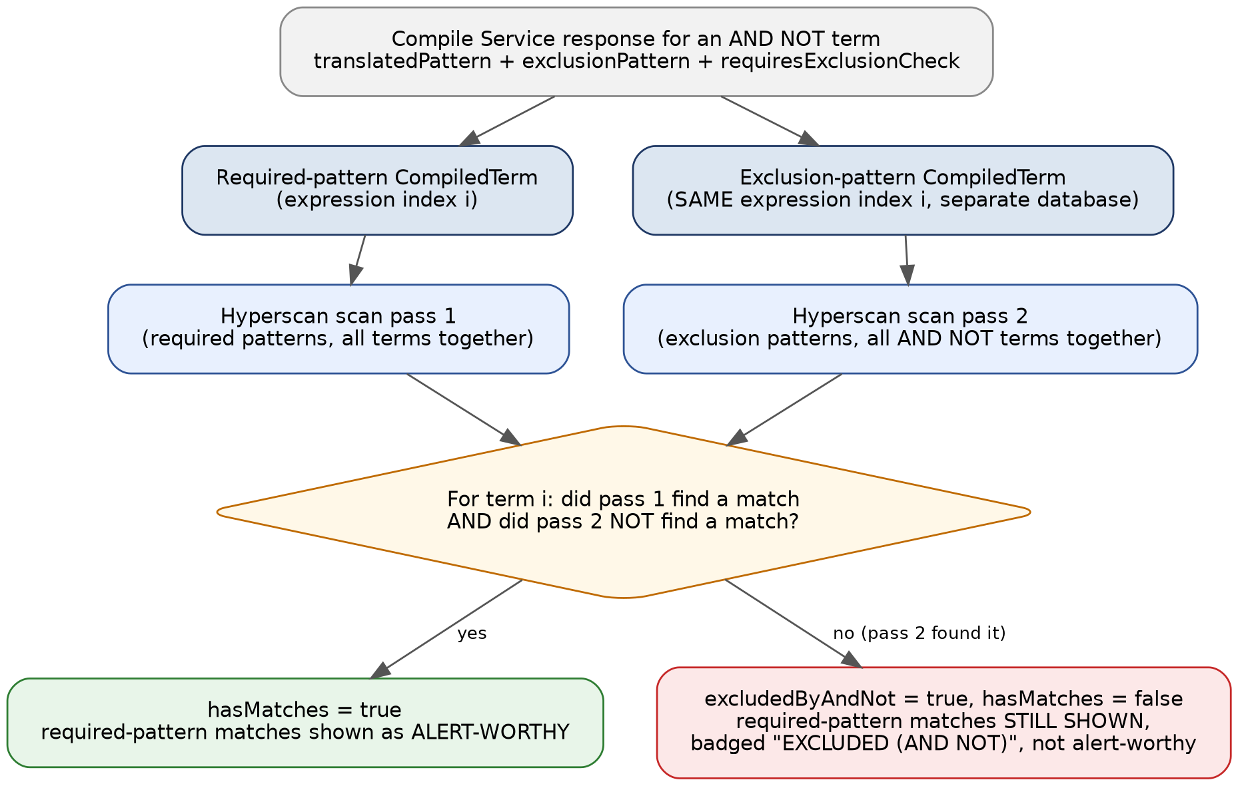
Figure 5: The two-pass scan that enforces AND NOT. Required and exclusion patterns are scanned separately; a term is only alert-worthy when pass 1 found it and pass 2 did not.

8.1 What Went Wrong Previously, and Why
At one point, the Compile Service renamed its response fields (hsFlags → hyperscanFlags, requiresAndPostFilter → requiresExclusionCheck, and added exclusionPattern as a new field). This service's own response model still expected the old field names. Because Jackson's @JsonIgnoreProperties(ignoreUnknown = true) only protects a consumer against a producer ADDING new fields — not against a producer RENAMING fields the consumer still expects by the old name — every AND NOT term silently deserialized to requiresExclusionCheck = false here, with the exclusion pattern never captured at all.
The practical effect: an AND NOT term behaved exactly like its required side alone. A term such as "schlechter AND NOT (Kein schlechter Preis)" would highlight "schlechter" as a match even when the excluded phrase was present in the same message, because this service never even knew there was an exclusion to check. This did not surface as an exception or a failed test — both services individually behaved exactly as designed against their own understanding of the contract. It surfaced only as a real user observing that a term which should not have matched, did.

8.2 The Fix: Field Alignment Plus a Genuine Second Scan Pass
Two things were required, and either alone would have left the bug in place:
- 1. Field alignment — this service's TermResult model was updated to match the Compile Service's actual current field names exactly, including capturing exclusionPattern for the first time.
- 2. A genuine second Hyperscan scan pass — previously, even with the correct fields available, nothing in this service actually compiled and scanned the exclusion pattern. The orchestrator now compiles every AND NOT term's exclusion pattern into a PARALLEL Hyperscan database — sharing the same expression index as its owning term's required-pattern database, so a hit in either pass can be attributed back to the correct term — and scans the SAME stripped message text a second time. A term is only alert-worthy when its required pattern matched in pass 1 AND its exclusion pattern did NOT match in pass 2.

8.3 What the Analyst Sees
An AND NOT term whose exclusion condition is present still shows its required-pattern matches in the UI, for visibility — but the term card is badged "EXCLUDED (AND NOT)" in a distinct colour, with an explanatory note, and it does not count toward the alert-worthy match total. This deliberately mirrors how disclaimer-only matches are shown (section 6.4): visible, explained, and explicitly not counted, rather than either hidden or silently counted as an alert.

8.4 Why Two Passes, Not One Combined Pattern
The Compile Service's /compile and /compile/csv endpoints (which this service calls) deliberately do NOT attempt to compile AND NOT into a single Hyperscan pattern — Hyperscan cannot express "absent from the whole message" in one ordinary pattern at all (no negative lookaround support). The Compile Service's /compile/bundle endpoint solves this differently, using a native Hyperscan logical-combination feature compiled directly into a database file — but that mechanism is specific to the combined-database bundle format the Scan Engine consumes, and is not what /compile or /compile/csv return. This service's two-pass approach is the correct, symmetric counterpart for a caller that receives two separate pattern strings and must combine their boolean results itself in application code.

9. Hyperscan Flags and Complexity Handling in the Scanner Service

9.1 Flag Bitmask: CASELESS, UTF8, UCP
For a Natural Language term, this service uses the hyperscanFlags bitmask exactly as returned by the Compile Service (CASELESS always; UTF8 and UCP added when the term contains non-ASCII content) — see the Lexicon Compile Service reference document, section 13, for the full flag model and the DOTALL discrepancy between term types. This service does not recompute or reinterpret that bitmask; it is converted directly into the equivalent Hyperscan ExpressionFlag set and used as-is.
For a Regex term, the same bitmask convention applies, but the flags are supplied directly by the caller alongside the pattern rather than derived from script detection — this service's own HyperscanScanService.validatePattern() compiles the pattern with whatever flags were provided.

9.2 SOM_LEFTMOST: Always On, No Opt-Out
Unlike the Compile Service's bundle endpoint (which offers a trackMatchPosition: false opt-out specifically for the batch Scan Engine's boolean-only alerting use case), this service ALWAYS adds SOM_LEFTMOST to every compiled expression, unconditionally, on both scan passes. There is no equivalent opt-out here, because this service's entire purpose is interactive highlighting — every scan result must be able to report exactly where a match starts in order to render it, so there is no scenario within this service where omitting start-of-match tracking would make sense.

9.3 QUIET and COMBINATION Flags: Not Used by This Service
The native Hyperscan logical-combination mechanism (ExpressionFlag.COMBINATION / QUIET), used by the Compile Service's /compile/bundle endpoint to embed AND NOT natively into a combined database, is NOT used anywhere in this service. This service's AND NOT enforcement is the two-pass application-level scan described in section 8 — a deliberately different, independently correct mechanism suited to a caller that reads two separate JSON pattern fields rather than a caller that only ever sees a compiled database file.

9.4 Pattern-Complexity Calculation: There Is No Separate Heuristic in This Service
This is worth stating precisely
Unlike the Compile Service, this service has NO PatternComplexityAnalyzer equivalent of its own, and performs no pre-emptive estimation of whether a pattern is likely to be "too large" for Hyperscan before attempting to compile it.
The two term types are protected very differently:
Term type | Complexity protection
Natural Language | Entirely external to this service. The Compile Service's PatternComplexityAnalyzer (see the Lexicon Compile Service reference document, section 12) runs as part of the /compile or /compile/csv call this service makes. If a term is rejected there, it arrives back at this service as an ordinary FAILED result with a translationError message — this service does not know, or need to know, that a complexity heuristic specifically was the cause.
Regex | NONE, pre-emptively. HyperscanScanService.validatePattern() calls this service's own embedded Hyperscan compiler directly, with no heuristic check beforehand. If the caller-supplied pattern is too structurally complex, Hyperscan's own real compiler rejects it at that point, and the failure surfaces as an ordinary FAILED validation result carrying Hyperscan's own error message ("Hyperscan rejected this pattern: ...") — functionally identical in shape to any other Hyperscan compile rejection, with no special-cased detection or messaging for the "pattern too large" case specifically.

In practice, this means a Regex-type term submitted directly to this service gets exactly the same protection level the Compile Service's OWN Regex-type terms get (see the Lexicon Compile Service reference document, section 4) — real Hyperscan validation with no pre-emptive heuristic — while a Natural Language term gets the benefit of the Compile Service's complexity analyzer indirectly, simply by virtue of every Natural Language term necessarily passing through the Compile Service first.

10. Multi-Message Scanning
A scan request can supply either a single pasted message (labelled "Pasted Message" throughout the response) or one or more uploaded files, each of which becomes its own independently-scanned message. All messages in one request share the same compiled term set and disclaimer set (section 3.1) — the Compile Service is called once regardless of how many messages are scanned, and each message gets its own MessageScanResult with its own highlighted HTML, matches, and disclaimer spans.

10.1 Why Share the Compiled Term Set
Compiling a term set (especially a Natural Language one, which requires a round-trip to the Compile Service) is materially more expensive than scanning one additional message against an already-compiled Hyperscan database. Sharing the compiled set across every message in a request — rather than recompiling per message — keeps a multi-file batch scan's cost proportional to the number of messages, not to messages × terms.

11. Validation and Exception Handling

11.1 Validation
- Term count ceiling: a configurable maximum number of terms per request (default 500, exposed via GET /api/scan/health as maxTerms), enforced before any Compile Service call or local compilation is attempted.
- Per-term failure isolation: a single bad term (a Natural Language term the Compile Service rejects, or a Regex term this service's own Hyperscan instance rejects) never fails the whole scan request — it is reported as a FAILED TermScanResult alongside every other term's PASS/matched results.
- Bean-level request validation: standard Spring @Valid / @NotEmpty checks on the incoming request shape (e.g. at least one term, at least one message).

11.2 Exception Types and HTTP Status Mapping
Exception | Thrown when | HTTP status
LexiconCompileException | The upstream call to the Compile Service fails outright — network error, non-2xx response the client can't otherwise interpret, or the Compile Service itself is unreachable | 502 Bad Gateway — correctly signals that the failure originates in an upstream dependency, not in this service or in the caller's request
CsvParseException | An uploaded lexicon-term or disclaimer CSV cannot be parsed | 400 Bad Request
MaxUploadSizeExceededException | An uploaded file exceeds the configured size limit | 413 Payload Too Large
Any other unhandled exception | An unexpected internal error during the scan pipeline itself | 500 Internal Server Error — logged server-side with full detail

As with the Compile Service, a GlobalExceptionHandler (@RestControllerAdvice) centralises this mapping, keeping the controller layer free of try/catch blocks and ensuring a consistent error response shape across both REST endpoints.

12. Downloadable Report
After a scan completes, an analyst can download a CSV audit report built entirely client-side from the already-fetched scan response — no additional server round-trip or re-scan. One row is produced per match, plus one row per term with no match, so every submitted term is represented for every scanned message even when nothing fired.
Column | Meaning
Message | Which scanned message this row belongs to — necessary once multi-message scanning (section 10) means a report can span more than one message.
Lexicon Term | The original term description.
Translated Regex | The Hyperscan pattern used for scanning.
Compilation Status | PASS or FAILED.
Request Type | Natural Language or Regex (section 4).
Matched Text | The specific text that matched, if any.
Flag for Alert | Yes only when the match is genuinely alert-worthy — No for disclaimer-only (section 6) or AND NOT–excluded (section 8) matches.
Was it Disclaimer? | Yes / No / N-A.
Excluded by AND NOT? | Yes / No — added specifically so the report stays consistent with what the UI's term-card badges show (section 8.3).

13. REST API Reference

13.1 POST /api/scan
Content-Type: multipart/form-data — the primary entry point from the web UI.
Parameter | Values | Notes
inputMode | TERMS | CSV | How lexicon terms are supplied
termType | NATURAL_LANGUAGE | REGEX | Default NATURAL_LANGUAGE (section 4)
messageMode | TEXT | FILE | TEXT = one pasted message; FILE = one or more uploaded files (section 10)
messageFiles | one or more files | Only when messageMode=FILE; each becomes its own scanned message
disclaimerInputMode | NONE | TEXT | CSV | Default NONE — disclaimer exclusion is optional (section 6)
disclaimers | text | Blank-line-separated disclaimer texts, when disclaimerInputMode=TEXT
disclaimerCsvFile | file | When disclaimerInputMode=CSV

13.2 POST /api/scan/json
Content-Type: application/json — for programmatic clients. Always single-message (text only) and text-only disclaimers; multi-file upload and disclaimer-CSV forwarding require a real file upload and are multipart-only, available only via /api/scan.

13.3 GET /api/scan/health
Service status and key configuration values, including the Compile Service URL and maxTerms (section 11.1).

14. UI Overview
The single-page UI presents, top to bottom: a Lexicon Terms panel (Natural Language / Regex toggle, then Type Terms / Upload CSV), a Communication Message(s) panel (Type/Paste / Upload File(s)), an optional Disclaimer Exclusion panel following the same type-or-upload pattern, a session name field, and Run Scan / Clear / Download Report actions. Results render per message: a highlighted-message view followed by one card per lexicon term, colour- and badge-coded by outcome — matched, no hit, failed, disclaimer-only, or excluded by AND NOT.

14.1 A Fixed UI Bug: File-Upload Confirmation
Selecting a file previously failed to visibly confirm the upload in some cases. The cause was a CSS flexbox interaction — the confirmation element had gained an overflow property (added to support scrolling for long multi-file-name lists), which, per the CSS flexbox specification, disables that element's implicit protection against being compressed below its content size when its flex container is tight on space. The fix adds an explicit flex-shrink: 0 to guarantee the confirmation text is never compressed away, plus a switch from a fixed dropzone height to a minimum height so the box can grow to fit longer content instead of forcing its children to compete for a rigid space.

15. Known Limitations
- Disclaimer matching is exact-substring only (section 6.5) — a disclaimer that varies between messages (e.g. a per-message date) will not be detected.
- No pattern-complexity pre-check for Regex-type terms (section 9.4) — a locally-submitted regex relies entirely on Hyperscan's own real-time rejection, with no early, specific "this is likely too complex" warning the way a Natural Language term gets from the Compile Service's analyzer.
- SOM_LEFTMOST is always on, with no opt-out (section 9.2) — unlike the Compile Service's bundle endpoint, there is no lighter-weight boolean-only scanning mode in this service, since interactive highlighting is its core purpose.
- The MockMvc-based controller test suite (ScanControllerTest) has been kept up to date in source but has not been compiled or run in the development sandbox used to build this platform, since doing so would require a disproportionate stub investment for a thin pass-through layer over already-verified orchestrator logic. It should be run for real in a genuine Maven build before release.
- Native Hyperscan behaviour — including the two-pass AND NOT scan's actual runtime matching, not just its construction — could not be executed against the real native library in the development sandbox used to build this platform. Verification there relied on structural checks and, where possible, an equivalent-behaviour Java-regex fallback path this service also supports for non-native-Hyperscan environments, rather than genuine Hyperscan execution for every code path.

16. Summary: AND, AND NOT, and "Pattern Too Large" At a Glance

16.1 AND
- This service's role: none beyond ordinary pattern compilation. AND is fully resolved into a single, self-contained Hyperscan pattern by the Compile Service (or supplied pre-resolved in a Regex term) before this service ever sees it — there is no AND-specific logic anywhere in this service.

16.2 AND NOT
- This service's role: the ONLY operator requiring genuine additional logic here. Implements the two-pattern JSON contract's caller side (section 8): compiles both the required and exclusion patterns, scans the same stripped message text twice, and combines the two boolean outcomes per term. A term is alert-worthy only when the required pattern matched AND the exclusion pattern did not.
- What the analyst sees: required-pattern matches for an excluded term are still shown, badged "EXCLUDED (AND NOT)", explicitly not counted as an alert.
- Historical note: a silent field-rename mismatch between this service and the Compile Service previously made every AND NOT term behave as if it had no exclusion at all — fixed by aligning field names AND adding the genuine second scan pass; either alone would have left the bug in place (section 8.1).

16.3 "Pattern Too Large"
- This service's role: passive for Natural Language terms (protection happens entirely inside the Compile Service call); NONE, pre-emptively, for Regex terms — only Hyperscan's own real-time rejection at compile time (section 9.4).
- A rejected Regex term surfaces as an ordinary FAILED validation result carrying Hyperscan's own error message, with no special complexity-specific detection or messaging in this service — unlike the Compile Service's Natural Language path, which has a dedicated, calibrated heuristic that rejects likely failures BEFORE Hyperscan is even invoked (see the Lexicon Compile Service reference document, section 12).

